BMI Calculation with Bootstrap

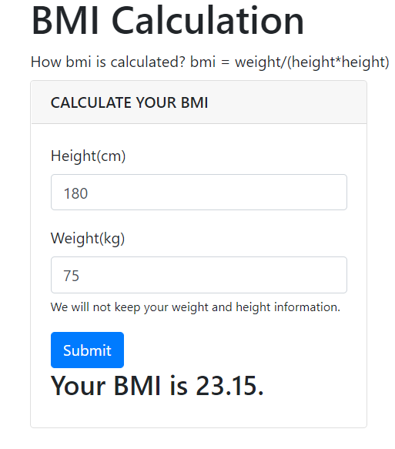

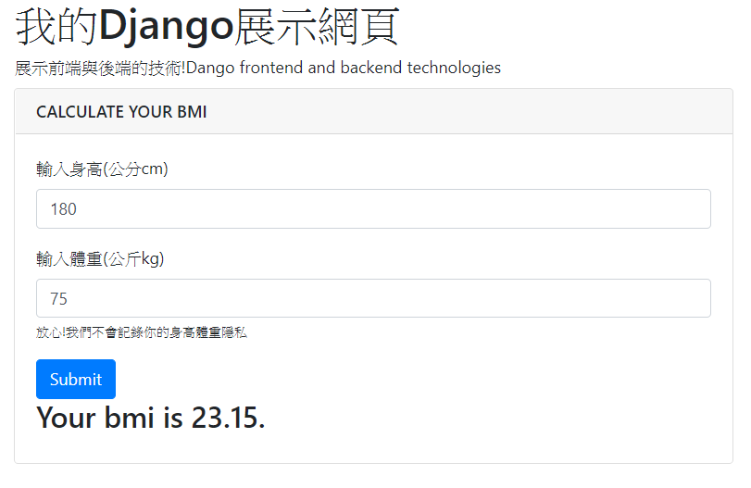

Step1: Create your project

mkdir website_bmi_v1

cd website_bmi_v1

Inside your django project folder, execute the following command to create a new project configure:

django-admin startproject website_configs .

Step2: Create your app

Inside your django project folder, execute the following command to create a new bmi app:

django-admin startapp app_bmi

or

python manage.py startapp app_bmi

Step3: settings.py

settings.py

|  |
| --- |
| ALLOWED_HOSTS = ['*']  INSTALLED_APPS = [  …..  'app_bmi',  ] |

注意: 你若使用PyCharm，會自動幫你把app加上，請不要自己再加一次，否則會有錯誤。

Step4: urls.py

開放哪一支網頁程式?名稱是甚麼?

urls.py

|  |
| --- |
| from django.contrib import admin  from django.urls import path  # from app_bmi import views as views_app_bmi  from app_bmi import views  urlpatterns = [  ~~path('admin/', admin.site.urls),~~  path('', views.home),  ] |

Step5: views.py

伺服器端準備甚麼資料傳送給網頁去呈現?

views.py

|  |
| --- |
| from django.shortcuts import render  def home( request ):  if request.method == 'POST':  h = request.POST.get('height')  w = request.POST.get('weight')  h = int(h)  w = int(w)  print(h,w)  bmi = round( w/(h/100)**2, 2)  return render(request, 'app_bmi/home.html',{'yourbmi': bmi} ) # submit  return render(request, 'app_bmi/home.html') # first time |

Step6: 網頁(templates)home.html

你的動態網頁程式要如何寫?

home.html 要置放在哪個目錄?

* 個別app目錄底下的 templates

website_bmi_v1/app_bmi/templates/app_bmi/home.html

|  |
| --- |
| <!-- home.html -->  <!DOCTYPE html>  <html lang="en">  <meta charset="utf-8">  <meta name="viewport" content="width=device-width, initial-scale=1">  <link rel="stylesheet" href="https://maxcdn.bootstrapcdn.com/bootstrap/4.3.1/css/bootstrap.min.css">  <script src="https://ajax.googleapis.com/ajax/libs/jquery/3.3.1/jquery.min.js"></script>  <script src="https://cdnjs.cloudflare.com/ajax/libs/popper.js/1.14.7/umd/popper.min.js"></script>  <script src="https://maxcdn.bootstrapcdn.com/bootstrap/4.3.1/js/bootstrap.min.js"></script>  <head>  <title>Get BMI</title>  </head>  <body>  <div class="container">  <h1>BMI Calculation</h1>  <label>How is bmi calculated? bmi = weight/(height*height)</label>  <div class="row">  <!-- row .. col-lg-6 .. card -->  <div class="col-lg-4 mb-5">  <div class="card">  <div class="card-header">  <h3 class="h6 text-uppercase mb-0">Calculate your BMI</h3>  </div>  <div class="card-body">  <form method="POST">  {% csrf_token %}  <div class="form-group">  <label>Height(cm)</label>  <input class="form-control" id="height" name="height" value="180" placeholder="Height(cm)">  </div>  <div class="form-group">  <label>Weight(kg)</label>  <input class="form-control" id="weight" name="weight" value="75" placeholder="weight(kg)">  <small>We will not keep your weight and height information.</small>  </div>  <button type="submit" class="btn btn-primary" >Submit</button>  </form>  {% if yourbmi %}  <h3>Your BMI is {{ yourbmi }}.</h3>  {% endif %}  </div>  </div>  </div><!-- end of card -->  </div><!-- row -->  </div> <!-- container -->  </body>  </html> |

注意:

用POST必須在form內部區域加上 {% csrf_token %}

<form>

{% csrf_token %}

</form>

|  |
| --- |
| <form method="POST">  {% csrf_token %}  身高輸入欄位  身高的input標籤  <div class="form-group">  <label>Height(cm)</label>  <input class="form-control" id="height" name="height" value="180" placeholder="Height(cm)">  </div>  體重輸入欄位  <div class="form-group">  <label>Weight(kg)</label>  <input class="form-control" id="weight" name="weight" value="75" placeholder="weight(kg)">  <small>We will not keep your weight and height information.</small>  </div>  <button type="submit" class="btn btn-primary" >Submit</button> 確認按鈕  </form>  如果yourbmi有值(空值不會執行這個區塊)  {% if yourbmi %}  <h3>Your BMI is {{ yourbmi }}.</h3>  {% endif %} |

Step7: Start server

現在啟動 web server

python manage.py runserver

連至

http://127.0.0.1:8000/

http://localhost:8000/

認識CSRF漏洞

CSRF是一種對網站的惡意利用(網路攻擊)。

全稱是 Cross Site Request Forgery，跨站請求偽造

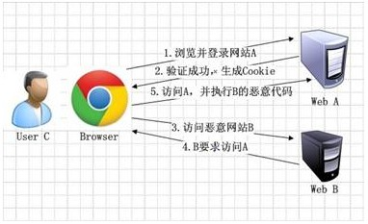

[圖片](https://www.jianshu.com/p/a178f08d9389)來源

Django內定啟動，跨站請求偽造（Cross-site Request Forgery，CSRF）防護機制。

Django是有啟用CSRF防護(內定啟用):

在項目的settings文件中有一個配置項MIDDLEWARE，表示默認Django啟用csrf認證。

'django.middleware.csrf.CsrfViewMiddleware'

因此:

當你的頁面為form表單提交時，需要在form標籤中加上{% csrf_token %}，在表單初次提交的時候帶上了csrf_token的資訊(就是一堆看起來是亂碼的編碼)給伺服器，伺服器端就會認為你是可信任的用戶。

Some basic HTML tags we need to know:

HTML tags

|  |  |  |
| --- | --- | --- |
| **HTML 碼** | **英文單字** | **說明** |
| <html>...</html> | HTML | 這是 HTML 文件。 |
| <head>...<head> | head | HTML 程式碼的頭，它負責傳遞資訊給瀏覽器，和瀏覽器溝通。 |
| <body>...</body> | body | body 就是 HTML 的身體或主體啦。 |
| <p>...</p> | paragraph | paragraph 就是段落的意思，所以，要表示一段文字為一個段落用<p>...</p>即可。 |
| <strong>...</strong> | strong | 加強語氣，所以用 strong 來表示加強的意思。 |
| <em>...</em> | emphasize | 強調語氣，所以用 emphasize 來表示強調的意思。 |
| <ul>...</ul> | Unordered List | Unordered List 的縮寫就是 ul，**沒有**標上序號的列表。 |
| <ol>...</ol> | Ordered List | Ordered List 的縮寫就是 ol，**有**標上序號的列表。 |
| <li>...</li> | List Item | List Item 的縮寫就是 li，是 "列表項目"，只能放在 <ul> 或 <ol> |

<ul id="message">

<li>Message 1</li>

<li>Message 2</li>

<li>Message 3</li>

</ul>

Bootstrap tags

|  |  |  |
| --- | --- | --- |
| < div class="container">...</div> | container | 容器 |
| <div class="row">...</div> | row | 列 |
| <div class="col-lg-12">...</div> | 行 | 行 |

<div class="container"> There is a container

<div class="row"> There is a row in the container

<div class="col-lg-12 mb-5"> There is a full column in the row

col-lg-12 a full-size-page

a full-size-page is divided into 12 columns

|  |  |  |  |  |  |  |  |  |  |  |  |
| --- | --- | --- | --- | --- | --- | --- | --- | --- | --- | --- | --- |
| 1 | 2 | 3 | 4 | 5 | 6 | 7 | 8 | 9 | 10 | 11 | 12 |

col-12 full page

col-6 means half page

col-4 1/3 page

<div class="col-lg-4 mb-5">

col-lg-4 4 large columns 1/3 of a full-size-column

mb-5 5 pixels margin-bottom

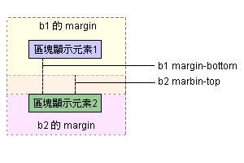

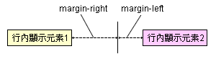

<https://sites.google.com/site/coolteazhuanti/css/padding>

CSS 排版定義了元素之間的彼鄰關係，每一個元素我們都可視它為一個 Box方塊，由以下四個屬性組成

margin(邊界)

border(邊框)

padding(邊距)

content元素內容

[上面留白值] [右邊留白值] [下面留白值] [左邊留白值]

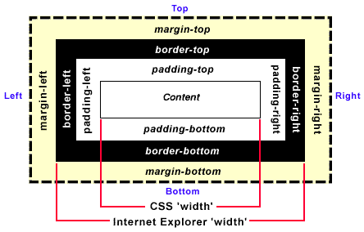

Some useful bootstrap elements

<input class="form-control" id="height" name="height" value="180" placeholder="Height(cm)">

More Bootstrap tutorials: <https://www.w3schools.com/bootstrap4/>

Django’s template language

Django’s template language is designed to strike a balance between power and ease. It’s designed to feel comfortable to those used to working with HTML. If you have any exposure to other text-based template languages, such as [Smarty](https://www.smarty.net/) or [Jinja2](https://palletsprojects.com/p/jinja/), you should feel right at home with Django’s templates.

|  |
| --- |
| {% **extends** "base_generic.html" %}  {% **block** title %}{{ section.title }}{% **endblock** %}  {% **block** content %}  <**h1**>{{ section.title }}</**h1**>  {% **for** story **in** story_list %}  <**h2**>  <**a** href="{{ story.get_absolute_url }}">  {{ story.headline|upper }}  </**a**>  </**h2**>  <**p**>{{ story.tease|truncatewords:"100" }}</**p**>  {% **endfor** %}  {% **endblock** %}  {% if yourbmi %}  <h3>Your BMI is {{ yourbmi }}.</h3>  {% endif %} |

<https://docs.djangoproject.com/en/3.1/ref/templates/language/>